ORLY VARDY / OUR WORLD

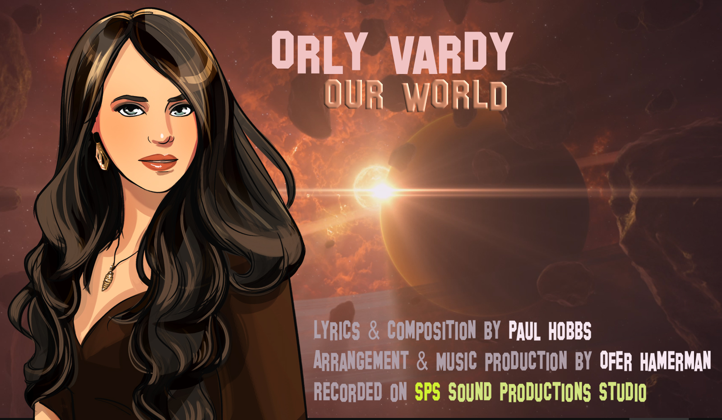

Click here to listen to the song in a few versions:
Orly Vardy – OUR WORLD (Official Radio Version)
Orly Vardy – OUR WORLD (Club Remix)
Orly Vardy – OUR WORLD (Ballad Version)

Check out the official clip on YouTube:
https://youtu.be/m-Y49AEano8

Check out the official page:
http://www.sps-productions.co.il/orly-vardy-our-world

ORLY VARDY

Orly Vardy, the 'Singer with the Gentle Voice' from Israel, has performed in prestigious events throughout Israel and around the world. Several of her songs have been successful in various international competitions; including Unisong USA during 2003-2009.
She has participated in several international projects such as; 'Ray of Hope', 'After the Rain' and 'The Lyricist'.
Her album 'A Million Love Songs' was released in 2012 and songs from the album were very successful on radio stations in the UK and across Europe, the USA and Australia.
She had the most plays of any singer in 2008 on Venture Radio UK and was chosen by their listeners as the ‘Artist of the Year’ in 2008.
She recently released her second International EP 'So Many Things to Say' and the album combines songs in several styles and genres which highlights Orly’s versatility as an artist.

Orly received a fantastic critique of her first album on the influential Smooth Jazz Magazine:
http://www.smoothjazzmag.com/information.php?information

Orly's official sites:
http://www.OrlyVardy.com
http://www.facebook.com/OrlyVardy
http://www.facebook.com/SoManyThingsToSay

'OUR WORLD'
Songwriter, Paul Hobbs, was born in Bristol and lives in Weston Super-Mare, UK. He has been writing songs for over 30 years and originally penned the song back in the 1980s under the title ‘My World’. In 2006, Paul was encouraged by Leopard Music (Music Publisher) to take the song back into studio to give it a fresh updated feel. The song was restructured with a new production and vocal was re-titled ‘Our World’.
Paul has always loved composing romantic pop ballads and walking by the sea and it was on one such coastal walk when he was inspired to write the lyrics to 'Our World'. The song has been described by many as a beautiful song, with a classic and timeless appeal and he rates it as one of his very best compositions.
Paul was thrilled when Orly Vardy selected the song and wanted to release it as her next single and is hoping ‘Our World’ will at last reach its full potential and achieve global success with Orly Vardy.

Credits:
Lyrics & Composition by Paul Hobbs
Arrangement & Music Production by Ofer Hamerman
Recorded at SPS Sound Productions Studio
http://www.sps-productions.co.il

Mastering of the Official Radio Version by Mr. Mig (Steve Migliore)
Orly Vardy's Comic Artwork by Cyan Tomato Studio
Clip Edit by Gili Daniel
Published by Leopard Music Limited

© 2017 All Rights Reserved

Industry enquiries to:
info@leopardmusicgroup.com
http://leopardmusicgroup.com/

